Rehabilitation System for Motion-Impaired (Parkinson's Disease) Patients with the Help of MoCap Suit

Final Year Project Proposal

Session 2016-2020
4th Year Student
A project submitted in partial fulfilment
Of
BS in Computer Science (CUI)

Department of Computer Science
COMSATS University Islamabad, Lahore

Project Registration
Project ID (for office use)
Type (Nature of project) |  |  | [] Development [] Research [*] R&D
Area of specialization
Project Group Members
Sr.# | Reg. # | Student Name |  | CGPA | Email ID | Phone # | Signature
(i) | FA16-BCS-081 | Arslan Riaz |  | 2.53 | chouhdaryarslan123@gmail.com | 0341-4243709
(ii) | FA16-BCS-045 | Imtisal Ahmad |  | 2.48 | imtisal.ahmed2@gmail.com | 0336-4253634
Name & Signature of Batch Advisor  (If students are eligible for FYP) |  |  |  | Mr.Imran Laftif

Plagiarism Free Certificate
This is to certify that, I am ARSLAN RIAZ S/o RIAZ AHMAD, group leader of FYP under registration number CIIT/FA16-BCS-081/LHR at Computer Science Department, COMSATS University Islamabad, Lahore. I declare that my FYP proposal is checked by my supervisor and the similarity index is 14% that is less than 20%, an acceptable limit by HEC. The report is attached herewith as Appendix A.
Date: 16/09/2019 Name of Group Leader: ARSLAN RIAZ Signature: _____________
Name of Supervisor: Mr. Imran Raza Co-Supervisor (if any): Dr. Syed Asad Hussain
Designation: Assistant Professor Designation: Professor/Dean (FIST)
Signature: _____________________ Signature: _____________________

Approval of FYP Management Committee
Committee Member 1: Name: _____________________
[ ] Accept [ ] Defer [ ] Reject Signature: _______________
*Remarks: _____________________________________________________________________
Committee Member 2: Name: _____________________
[ ] Accept [ ] Defer [ ] Reject Signature: _______________
*Remarks: _____________________________________________________________________
Convener: Name: _____________________
[ ] Accept [ ] Defer [ ] Reject Signature: _______________
*Remarks: _____________________________________________________________________

Abstract:
More than 10 million people are affected by motion diseases like Parkinson’s disease around the globe which is alarming. So, experts around the world are working to find new and effective ways to cure these patients using various technologies and experimenting with many upcoming technologies. The proposed system targets Parkinson’s disease patients and provides an interactive and innovative solution using cutting-edge technology like Mo-Cap suit. The main architecture of the project works on motion sensors. Pre-defined tasks like exercise will be performed by the patient wearing the Mo-cap suit and the values obtained from movement through the sensors will be used by the system to evaluate the task, based upon the progress made by the patient after completing the task. The recovery rate and performance of the patient are monitored, observed and stored in the database which will be used to create progress reports/ rate of recovery.

Table of Contents
1. Introduction 7
1.1 Optical Mo-Cap Suit 7
1.2 IMU Sensor-based Mo-Cap Suit 8
2. Motivation and Scope 8
3. Related Work 9
4. Goals and Objectives 10
4.1 Main Goals 10
4.2 Objectives 11
5. Proposed System 11
5.1 Recording 3D Animations of Healthy Person 12
5.2 Environment and Task Creation 12
5.3 Real-time Motion 12
5.4 Comparison and Evaluation 13
5.5 Progress Management 13
6. Individual Tasks 13
7. Gantt Chart 14
8. Tools and Technologies 14
9. Conclusion 14
10. Future Work 15
11. References 16
Appendix A: Turnitin Originality Report 18

Table of Figures
Figure 1- Optical Mo-Cap suit 7
Figure 2- IMU Mo-Cap suit 8
Figure 3- Motion-Builder 10
Figure 4-System Architecture 12
Figure 5- Gantt Chart 14

Introduction
An estimated 10 million people around the globe suffer from motion diseases like Parkinson’s disease which is an alarming number. These diseases affect patients’ quality of life, making their social life very difficult and disturbing their financial condition, because of the expenses related to the disease. Motor neuron diseases also known as motion diseases affect a person’s physical movements causing problems in gait movement, tremor, lack of control in balance, stiffness in limbs and muscles and slow movement etc. These diseases include Parkinson’s disease, Cerebral Palsy, and Dyskinesia etc.
Population studies about Parkinson’s are important to scientists’ understanding of the history of the disease, its evolution, and the risks associated with it. The information about the disease can help healthcare experts in designing different cures to meet patients’ needs [1]. According to experts by capturing motion details of motion impaired patients and analysing the collected data to find specific patterns can be very helpful in finding a cure for these diseases. Motion capture referred as Mo-Cap is the process of recording/capturing physical movements of objects or people used for medical applications, military purposes, games and validation of computer vision etc [2]. Motion capture smart suit is a device that captures and measures the real-time movement of people and provides necessary data which can be used to create 3D animations, evaluate different types of motions.
There are two basic types of motion capture suits

Optical Mo-Cap Suit
Optical Mo-Cap systems use video cameras and depth sensors to track the motion of markers attached to specific locations of the user`s body. It’s a process of recording human actions and translating them into animations by filming sensors on every point on the patients` body. Footage is captured and then converted into a 3D humanoid model. It is mostly used in film making and game making etc [3].
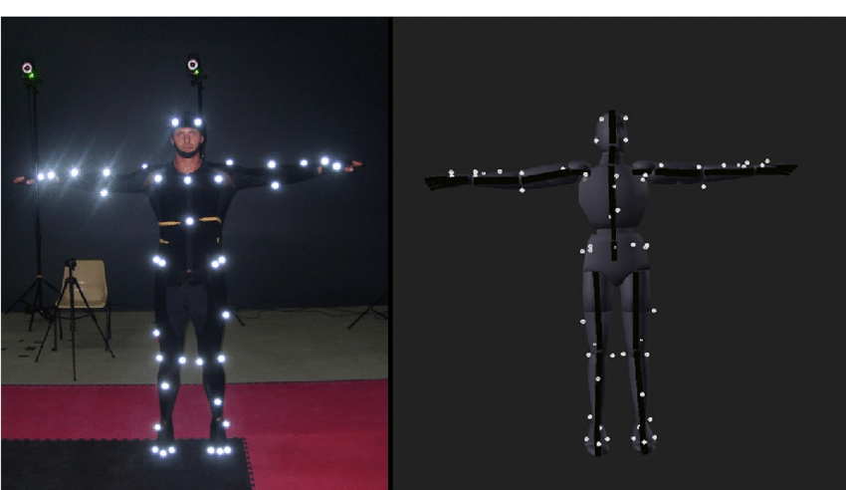
Figure 1- Optical Mo-Cap suit [3]

IMU Sensor-based Mo-Cap Suit
IMU-based (Inertial Measurement Units) Mo-Cap systems use IMUs to capture and rebuild human pose without the need of external visual sensing. The key goal is to capture people moving in the wild, performing unscripted actions and natural interactions without constraints. IMU sensors measure rotations and decode them onto a humanoid rig in the software. The more IMU sensors used the more natural the data. This system does not require any cameras, markers and emitters. IMU systems capture the complete 6 degrees of body motion of a user in real-time. These are mostly used for medical applications and aeronautics etc [4, 5].

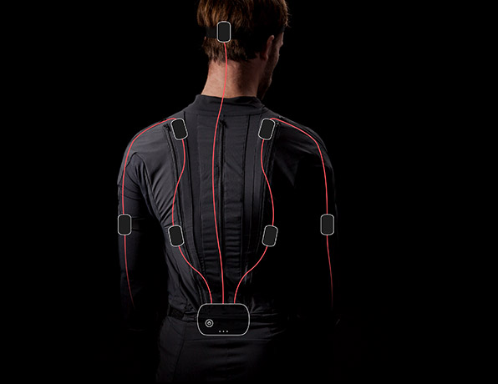
Figure 2- IMU Mo-Cap suit [6]
Motion capture system was initially used for the assessment of motion-impaired individuals to analyse patients’ walking gait patterns and movement of different body parts. The movement of each body joint is recorded accurately and by merging this data with the results of physical inspections, doctors can understand how and why a patient is moving in a specific way and makes some recommendations for the cure and therapy.
This project will use a motion capture suit to collect data from the body joints of a person and use this data in various forms to create an accurate rehabilitation system for Motion-Impaired (Parkinson's disease) patients.

Motivation and Scope
- According to Neurology Awareness & Research Foundation (NARF) PAKISTAN, a rough estimate is that 1 million Pakistanis suffer from Parkinson’s disease [7], moreover an estimated 10 million people worldwide have Parkinson’s disease [8]. This motivates us to create an efficient and Interactive rehabilitation system that transform tedious therapy into entertaining exercises.
- Mo-Cap has been leaving its unique mark on a numeral other industry, mostly in the medical field. This cutting-edge technology has allowed the quality of healthcare to improve for several people with devastating injuries and long-lasting circumstances that affect their capability to move and function in their daily lives, as well as changing the way many physiotherapists approach patient’s rehabilitation and care [9].
- Motion capture suites expand the possibility of recognition and rehabilitation of various motion diseases by providing detailed data of movements of different body parts.
- In medicine, MoCap is mostly used in gait analysis, but many different applications for this technology are also being discovered day by day, as well as the connection between body motion and the brain, including hand-eye synchronization [9].

Related Work
A VR dodge ball game based on the trending motion capture technology has been developed by the researchers with the target of reducing the fear induced by the motion. The purpose of this game was the transformation in the methods of movement of patients to upgrade their motion ranges [10].
Motion capture is being used to track athletes’ body motion to see how they can enhance their performance reducing the risk of injury with the help of the data obtained using Mo-Cap. Motion capture tracks athletes’ real-time body motion and analyses their performance, technical expertise, physical condition and injury mechanism etc. for example balance and neurocognition are the two main factors being studied to help sports medicine staff choose when its safe for concussed persons to return playing game [10,11].
Recently some studies were conducted to see if video game could replace regular exercises for parkinson’s or not. Experts and game developers came together to create beneficial games and consoles that display player’s movements. They deduced that these games can help patients as they do technically tested movements for the improvement of mobility, balance and overall wellness [12,13].
Interactive systems are being made day by day with the aim to help in the engagement of patients on various therapies. In some recent technological advancements, Kinect™ by Microsoft (Redmond, WA) has helped tile the way on how user interaction technology facilitates and complements many different clinical applications [14].
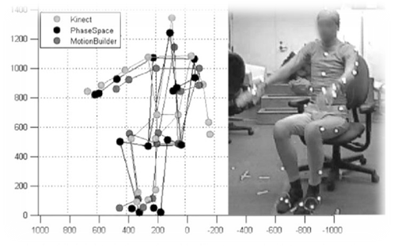
Figure 3- Motion-Builder [14]
Biofeedback for neuromotor rehabilitation. According to Journal of Neuro-Engineering and Rehabilitation volume 3, Article number: 11 (2006), The idea of task-oriented training proposes that biofeedback therapy should be carried during dynamic movements to improve motorized function improvement, a framework to increase the usage of task-oriented biofeedback therapy in neuromotor treatment [15].
According to a study newly emerging area of research based on games and their use in the field of healthcare can play an important role in rehabilitation of parkinson’s patients as they deal with 3d input and output. A full-body Mo-cap system with a bio-signal attainment is recently integrated with a game engine for this purpose. Also, a system is established to acquire skeletal data from serious games and a serious game is deployed for the rehabilitation of patients of neck and lower back pain [16].

Goals and Objectives
An Interactive and innovative Rehabilitation System for motion-impaired (Parkinson's) patients for the improvement of their body movements with the help of various Interactive exercise tasks and Games.

4.1 Main Goals
- Our main goal is rehabilitation for motion-impaired (Parkinson's) patients that are unable to perform their daily life activities properly due to the lack of limited body movement.
- Daily therapy can be extremely boring and tiring. So, we aim at transforming everyday tedious therapy into entertaining exercises that patients might find interesting.
- As the task would be performed by patients, their recovery data would be recorded so we also aim at monitoring the Improvement of patients very precisely and accurately which would be convenient for doctors and patients too.
- As the daily tasks/exercises will be interesting, interactive and entertaining so patients will not get tired and take interest in the recovery process as well as our system ensures precision that will eventually increase the Recovery rate.
- Our project is based on IMU sensors-based Mo-Cap suit which gets precise rotations and movement data of each body joint. Therefore, we aim to get a detailed insight into the patient`s motion.
- Our system will be continuously monitoring the progress made by the patient during the performance of tasks. So, it will also be evaluating the pace of recovery based on the progress made by the patients and storing the record in a secure database.

Objectives
- Improve the exercise methods of rehabilitation to new accuracy by using Cutting-edge technology.
- Introduce an easy, fun and Interactive way of therapy that will increase doctor-patient engagement.
- Making it easy for doctors to get adequate and detail information about the motion of body parts of the patients with visual representation.
- Record keeping of each patient, his history, recovery, and progress in a secured database.

Proposed System
The proposed system will have prerecord3D animations of various exercises created through the date provided by Mo-Cap Suit of a healthy person loaded in this interactive system which will then be compared against the real-time movement of the patient. The patient will have to wear a Mo-Cap Suit which will provide real-time motion data of the patient. The patient`s task will be to try to copy/overlap the rerecorded animations and system will evaluate the difference between the healthy person`s movement and patients’ motion. So, by performing these tasks the patients will go under exercise therapy in an accurate way. The progress made by completing those tasks will provide sufficient information and data to system, which will then evaluate the rate of recovery of patient. Similarly, different interactive tasks in the form of games will be present in the system to reduce the motion fear and for balance problems faced by some patients.
Following is the system architecture diagram and main modules of the proposed system.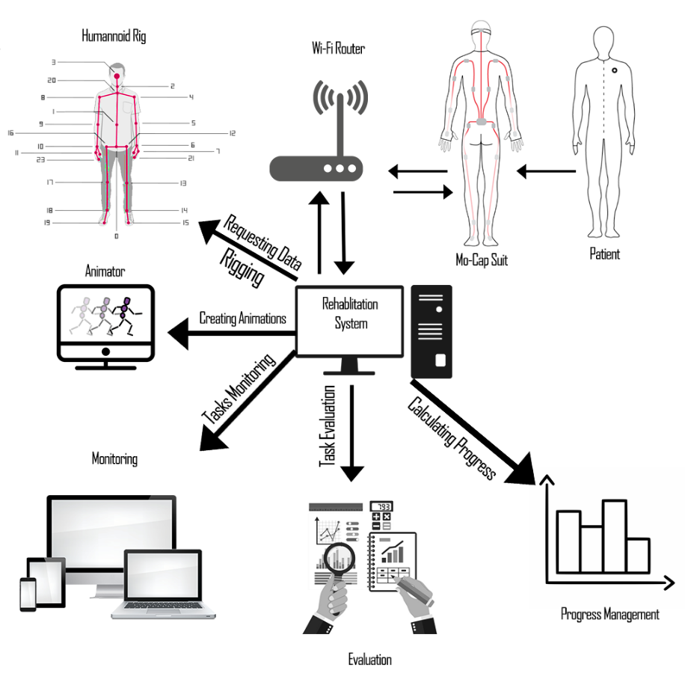
Figure 4-System Architecture

5.1 Recording 3D Animations of Healthy Person
Exercises performed by a healthy person wearing Mo-Cap Suit under the supervision of physiotherapists will be recorded and converted into 3D Humanoid animations using Unity 3D. These animations will contain the detailed movement data of each joint of the body of healthy persons like position, rotation, and angle etc. These animations will be applied to a humanoid 3d character.

5.2 Environment and Task Creation
A 3D interactive environment with different objects will be created with which the patient can interact in real-time. A set of different tasks just like exercise will be created using the 3d animations recorded from the healthy person as objectives of the tasks that the patient needed to complete. Each task will have different animation and difficulty levels depend upon the patient`s disease type and state.

5.3 Real-time Motion
The patient has to wear the Mo-Cap suit and perform the different tasks provided by the system. The real-time motion of the patient will be captured and sent to the system via Wi-Fi router and applied to another 3d humanoid character.

5.4 Comparison and Evaluation
This phase of the system will compare the data obtain from the animations of the healthy person against the real-time data of the patient and evaluate the difference between the joints movements of a healthy person and a motion-impaired person and evaluate either the patient completed or failed the task.

5.5 Progress Management
In this phase, the system will calculate the progress made by the patient by evaluating the whole set of tasks performed by the patient and uploaded to the online database system to keep the record of each patient.

Individual Tasks
In this part, Table 1 indicates the distribution of tasks between the members of the group.
Group Members | Registration ID | Tasks
ARSLAN RIAZ | F16-BCS-081 | - Research  - System Development  - 3D modeling / Graphic designing  - Task and environment designing  - Rigging and animating 3D models  - Networking and connection
IMTISAL AHMAD | FA16-BCS-045 | - Research  - System Development  - Recovery Progress Management  module  - Database Management  - Task Evaluation
Table 1- Tasks

- Gantt Chart
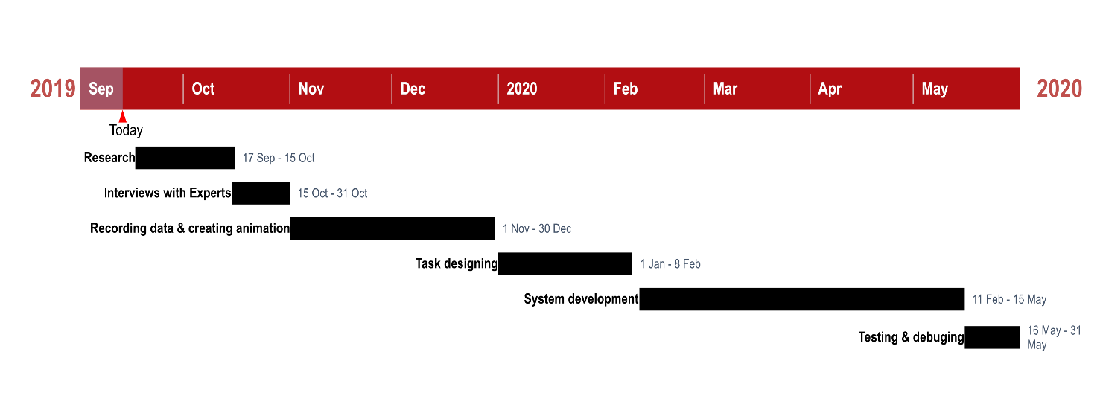
Figure 5- Gantt Chart

Tools and Technologies
- Languages:
C#
Java
- Tools:
Unity 3D
Unreal Engine
Firebase
Mo-Cap Suit
WIFI Router
Rokoko Studio
3Ds Max
Visual Studio
Microsoft Kinect

Conclusion
The proposed system will provide a dedicated Rehabilitation of Motion-Impaired (Parkinson's) patients with the help of motion capture. This system will increase the rehabilitation rate of the motion impaired people and motivates the patients toward therapy. In this system, we will convert everyday tedious therapy into entertaining exercises. So, by performing these interactive exercises/tasks the patient will undergo a bunch of physical exercises that will affect the patients’ body motion. The system will take the real-time data of the movement of body joints of the patients and compare them with values of the healthy person to evaluate the difference.

Future Work
- New game tasks for Tremor control using ‘Leap Motion’ for hand gestures and controls which will help the patients for better and strong grip.
- The whole system will be in Virtual Reality which will help the patient to completely indulge in the system helping the patient in a unique environment.
- Improvement in the preloaded tasks on the basis of feedback and more features that will help both patients and doctors.

11. References
[1] “Population studies on the incidence of Parkinson’s” from https://parkinsonsnewstoday.com/parkinsons-disease-statistics/ accessed on 12 September 2019.
[2] “Motion capture” from https://en.wikipedia.org/wiki/Motion_capture, accessed on 8 September 2019.
[3] “Optical motion capture” from https://metamotion.com/motion-capture/optical-motion-capture-1.htm accessed on 11 September 2019.
[4] “IMU-based Mo-Cap suit” from https://ps.is.tuebingen.mpg.de/pages/inertial-motion- capture, accessed on 11 September 2019.
[5] “IMU-based Motion capture system” from https://tracklab.com.au/inertial-motion-capture-systems/ accessed on 11 September 2019.
[6] “Rokoko SmartSuite Pro” from https://www.google.com/url?sa=i&source=images&cd=&cad=rja&uact=8&ved=&url=https%3A%2F%2Fmocap.reallusion.com%2Ficlone-motion-live-mocap%2Frokoko.html&psig=AOvVaw1E-5CJrYTyXj11kTttlarj&ust=1568462828016992, accessed on 8 September 2019.
[7] “Parkinson’s estimate by NARF” from https://www.pakistantoday.com.pk/2018/02/14/one-million-pakistanis-suffer-from-parkinsons-disease/, accessed on 8 September 2019.
[8] “Parkinson’s estimate” from https://parkinsonsnewstoday.com/parkinsons-disease-statistics/, accessed on 8 September 2019.
[9] “Physical therapy specialists approach an individual’s rehabilitation and care” from https://www.ecnmag.com/article/2014/08/motion-capture-software-and-medical-innovation, accessed on 8 September 2019.
[10] “Virtual dodge-ball game” from https://medcitynews.com/2015/07/life-in-motion/?rf=1, accessed on 8 September 2019.
[11] “Motion capture systems to see how athletes’ body movements” from https://www.researchgate.net/publication/314879089_Application_of_motion_capture_technology_for_sport_performance_analysis accessed on 9 September 2019.
[12] “Study to see if special video games could replace regular exercises” from https://www.cnet.com/news/parkinsons-patients-test-video-games-as-therapy-video/, accessed on 8 September 2019.
[13] “Study to see if special video games could replace regular exercises” from https://www.michaeljfox.org/news/are-video-games-potential-therapy-parkinsons-disease, accessed on 9 September 2019.
[14] “Intention to help in the engagement of patients on various therapies using Microsoft Kinect” from https://www.semanticscholar.org/paper/Motor-Rehabilitation-Using-Kinect%3A-A-Systematic-Gama-Fallavollita/90fe2333ff0fed80d342337f9c242bf5a81d9d2b,accessed on 12 September 2019.
[15] “Biofeedback for neuromotor rehabilitation” from https://jneuroengrehab.biomedcentral.com/articles/10.1186/1743-0003-3-11, accessed on 12 September 2019.
[16] “Serious games and particularly their use in healthcare applications” from https://dl.acm.org/citation.cfm?id=1959830, accessed on 12 September 2019.

Appendix A: Turnitin Originality Report
